Linux Terminal Commands – Manipulating the System
Dan Richter
07 Sep 2020

In this write-up, I’ll show you some commands that will give you information about your system. Some of these are pretty in-depth, so I’ll just show you the basics for them.

uname

This command will give you specific information about your system, including name, version and other details. As you can see in this example, the ‘uname -a’ gives all information. OS, System name, Linux kernel version, etc.

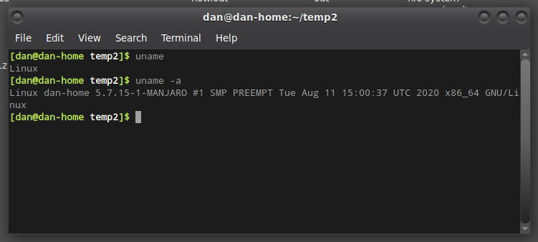
ps

The ‘ps’ command will tell you what is currently running on the system. Just a basic ‘ps’ command will tell you what is running in that window. There are many more options available for ps that will give you more information.

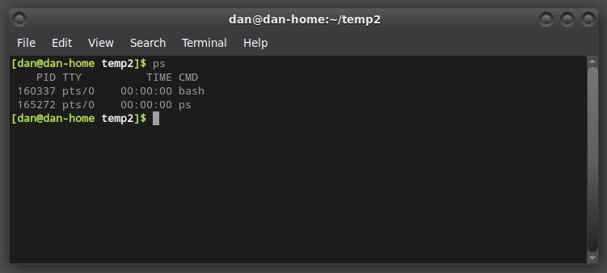

kill

The ‘kill’ command is a very powerful tool that will stop a stuck process.

service

The ‘service’ command will allow you to start or stop services on your system.

shutdown

This command does exactly what it sounds like. From the terminal, you can issue the ‘shutdown’ command, to shut your computer down.

restart

This is another command that does what it sounds like. It will restart your computer from the terminal.

